Algebra 3-4 Name: _______________________
Worksheet Block: ______

Graph the quadratic function. Label the vertex and axis of symmetry.

1. 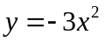 2. 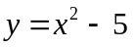
10
10
-10
-10
10
10
-10
-10

3. 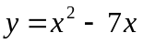 4. 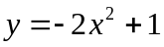
10
10
-10
-10
10
10
-10
-10

5. 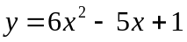 6. 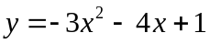
10
10
-10
-10
10
10
-10
-10

7. 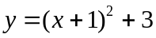 8. 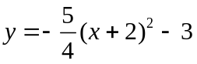
10
10
-10
-10
10
10
-10
-10

9. 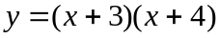 10. 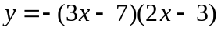
10
10
-10
-10
10
10
-10
-10

Write the quadratic function in standard form.
11. 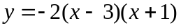 12. 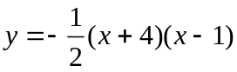

13. 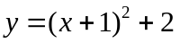 14. 